**Annex 4 – BMZ NARRATIVE INTERIM REPORT**

**Christoffel-Blindenmission Deutschland e.V.**

Project Details

|  |  |
| --- | --- |
| CBM Project Number: | 4111_BMZ-MYP(P00044) |
| BMZ Project Number: | 5226 |
| Project Title: | HEALTH RIGHT: Inclusive Eye and Ear and Hearing Health in Karnali of Nepal |
| City/ Country /Region: | Nepal |

|  |  |
| --- | --- |
| Name of Contractual Partner: | Nepal Netra Jyoti Sangh NNJS |

|  |  |
| --- | --- |
| Duration of Project: | 37 months |
| Project Start Date: | 01.12.2020 |
| Project End Date: | 31.12.2023 |

|  |  |
| --- | --- |
| Report Submitted by: |  |
| Name: | Man Bahadur Kunwar |
| Designation: | Project Manager |
| Email Address: | manbahadurk@nnjs.org.np |

|  |  |
| --- | --- |
| Reporting Period: | 2023.01.01 – 2023.06.31 |
| Date of Submission: | 2023.07.13 |

1. General Information
   1. **Project Short Description / Project Goal**

Karnali is one of the most underdeveloped provinces in Nepal. Basic health service for majority of population is still unavailable and not accessible because of various factors. People have little access to affordable eye and ear care which is fundamental factor influencing the prevalence of blindness and deafness. Surkhet eye hospital, located at province capital in Surkhet is only referral and treatment centre for whole province. This project aims to improve the quality of life of poor population of Karnali province affected by visual and hearing impairment by ensuring affordable IEEH service through existing health system, raising awareness on prevention and treatment of eye and ear disease and enhancing professional capacities of service provider.

**Sources of Information (10 lines)**

*Where was the information for the report taken from?*

1. Monthly Progress report
2. Screening data by the community coordinators
3. Workshops/seminar reports/attendances
4. Screening eye and ear camps records
5. Meeting minutes
6. Training reports
7. Surkhet Eye Hospital data
8. Province Hospital data
9. Eye surgical camps data
10. Data from newly established Primary Eye Centres
11. Data from supported health facilities
12. Early detection in Mass Screening Data
13. Financial documents
14. Field visits /monitoring reports
15. Status of Implementation of the project

*The impact matrix reflects a current-status in every bi-/annual report*

*All data should be disaggregated (women, men, girls and boys, person with disabilities, no duplications please), if possible.*

|  |
| --- |
| **Overall objective (impact):** The quality of life of the poor population of the province of Karnali affected by visual and hearing impairments is improved. |

**To reach the Overall Objective, the Project aims to reach 4 Results, each equipped with indicators:**

|  |  |  |  |  |  |
| --- | --- | --- | --- | --- | --- |
| **Specific Objective** (Outcome) | **Indicators** | | | | |
| Target | Achievement only in current reporting period in numbers  (quantitative & qualitative)  (2023.01.01 – 2023.06.31) | Achievement in previous reporting period in numbers  (2021 to 2022) | Total accumulated achievement till June 2023 (cumulative) | Description of achievement so far. Explanation for over-achievement or underachievement of the indicators. |
| Affordable quality IEEH services are part of the health system of the province of Karnali and treatment for poor people is secured. | The population practices measure to prevent eye and ear health (measured by survey). |  |  |  |  |
| 11,920 poor people have received treatment for their eye or ear disease. | Total no. of people received eye or ear services = 5556  ***(2925 cataract surgeries and 2631 ear treatments from Province***  ***Hospital)*** | Total eye and ear services received = 9347 | Cumulative achievement = 14903 | For this indicator, we track the no. of cataract surgeries from Surkhet Eye hospital from June 2021 and from outreach camps supported by the project.  Similarly, we track the no. of ear services received from Karnali Province Hospital since January 2022.  Both the hospitals are the technical partners of the project and we have supported for the upgradation of their services.  Through the support by the project for the upgradation and outreach eye surgical camps, no. of people accessing the eye and ear services has been increasing. |
|  | An agreement for the integration of the established IEEH services into the health system of the province of Karnali has been agreed with the government and ratified in writing. Defined requirements for inclusive barrier-free services are an integral part of the agreement. | In the reporting period, we organized a consultation provincial level workshop in Surkhet to review provincial eye health strategy by key member of province. After the input of workshop, provincial eye health strategy is now under review of ministry of social development and expected to endorse by Q3 of this year | # We organized 1 national and 1 provincial level workshop to discuss over the proposed eye health strategy in Kathmandu and Surkhet respectively in 2022 and  #the Ministry of Health and Population has already endorsed national eye health strategy |  | The project will continuously lobby, coordinate and advocate for making the strategies more inclusive and endorsement. Once the government endorses them, only then the agreement of established IEEH services into health system will be materialized. |

|  |  |  |  |  |  |
| --- | --- | --- | --- | --- | --- |
| **Results** (Output) | **Indicators** | | | | |
| Target | Achievement only in current reporting period in numbers  (quantitative & qualitative)  (2022.01.01 – 2022.12.31) | Achievement in previous reporting period in numbers  (2021 Annual) | Total accumulated achievement up-to-date December 2022 (cumulative) | Description of achievement so far. Explanation for over-achievement or underachievement of the indicators. |
| Result 1.  The population of the 4 target districts of Jumla, Surkhet, Dailekh and Mugu is aware of measures for the prevention and treatment of eye and ear diseases as well of the IEEH services being offered. | By the end of 2023, the population has been made aware of prevention as well as eye and ear treatments and informed about integrated services through 8 street theatres, 60 murals and 8 information panels in public places, 4 school competitions, radio spots and 32 events on special holidays | # Street theatres= 8  # Murals= 60  # Information panels=32  # School Competitions=3  # Public Celebration = 6 | #Street theatres =8  #Murals = 0  #Information panels =0  #School competitions = 9  # Public day celebration = 26 | Street theatres =8  #Murals = 60  #Information panels =32  #School competitions = 12  # Public day celebration = 32 | Achieved the overall project targets |
| 320 traditional healers, 20 Female Community Health Volunteers, 80 parents, 16 teachers, 16 community representatives were trained in the prevention and treatment of eye and ear diseases | Traditional healers= 89  FCHVs=0  Parents = 114 | # Traditional healers = 250  # FCHVs = 329  # Parents = 281 | # Traditional healers = 339  # FCHVs = 329  # Parents = 395 | # achieved the targets of the project |
| 90 health workers, community and district authority representatives were trained on disability, inclusion and inclusive emergency response. | Accomplished in 2022 | Trained in Emergency response measures= 101 | Trained in Emergency response measures= 101 | We have accomplished the targets. |
| 16 health care facilities are barrier- free. | Completed in Q2 of 2022 | Completed = 16 | No. of health care facilities completed their accessibility works = 16 | Targets have been achieved |
| 4 DPOs with 100 members have strengthened their lobbying skills and are committed to inclusion and accessibility. | Completed in 2022 | # No. of DPOs members trained on disability and inclusion = 99 | # No. of DPOs members trained on disability and inclusion = 99 | We have met 99% of the targets |
| Result 2.  In the target districts of Jumla, Mugu, Surkhet and Dailekh professional capacities and infrastructure for affordable IEEC services are permanently guaranteed. | 12 basic health stations and 4 primary health centres are equipped with basic ophthalmic and ear care services in the target communities. | # No. equipped basic health stations = 5 | # No. equipped basic health stations = 12  # No. of equipped primary health centres = 4 | # No. equipped basic health stations = 17  # No. of equipped primary health centres = 4 | #Achieved the overall targets of the project |
| 8 community coordinators and 25 community nurses working in the 16 health stations are trained in ophthalmology. They are integrated into a referral system with 2 eye clinics and 1 ENT department at the tertiary provincial hospital. | # Completed in 2022 | # No. of community coordinators trained =8  # No. of community nurses trained = 115 | # No. of community coordinators trained =8  # No. of community nurses trained = 115 | Already achieved the total targets of whole project period, the trained nurses and community coordinators are providing services in regular basis. |
| 2 eye clinics and 1 ENT department of the tertiary provincial hospital have received necessary medical equipment for further treatment and work together with health stations. 22 health workers were trained in audiology and 1 technician in maintenance of medical equipment. | # Completed in 2022 the equipments support  # Health workers trained in audiology = 5 | # Eye clinics equipped =2  # ENT Department supported = 1  # Health workers trained in audiology = 20  # Technician trained = 1 | # Eye clinics equipped = 2  # ENT Department supported = 1  # Health workers trained in audiology = 25  # Technician trained = 1 | #Achieved the overall project targets |
| 126,000 people participated in 32 mass screenings in schools and communities. | # No. of people participated in mass screenings = 29592 | # No. of people participated in mass screenings = 95272 | # Total No. of people participated in mass screenings up to date= 124864 | The project target for mass screening is on track. |
| 3,200 people were screened in 18 community screening programmes for early detection of hypertension, retinopathy, and glaucoma. | # No. of people screened for early detection = 2889 | # No. of people screened for early detection = 1023 | # No. of people screened for early detection = 3912 | # we achieved the whole project targets |
| 8,400 poor people from the communities have received cataract surgery and 320 people have received ear treatment. | # No. of people received cataract surgery = 2906(1511 BMZ Support)  # No. of people received ear treatments = 352 (324 from ear health camps and 28 ear surgeries from ENT Department of Province Hospital) | # No. of people received cataract surgery = 7045  # No. of people received ear treatment = 66 | # No. of people received cataract surgery = 9951  # No. of people received ear treatment = 418 | Till June 2023 from June 2021, total of 9951 cataract surgeries have been done by SHE and outreach surgical eye camps. Out of them, a total of 3639 cataract surgeries were supported by BMZ Project. We have achieved the total targets and will continue reporting till December 2023.  # the targets for ear treatments have been achieved and we will conduct another 1 ear health camp within Q4. |
| Result 3. Integration of accessible IEEH services in the state health system is ensured. | In 4 lobbying meetings with representatives of the district and provincial authorities, transfer of established IEEH services to the provincial medical health system was approved and signed. | Lobbying meeting conducted=1 | Lobbying meeting with Ministry of Social Development (MoSD) = 1 | Total Lobbying meetings conducted = 2 | The project organized a lobbying meeting with provincial and local government authorities April 2023. They committed strongly for the integration of eye care services under their ownership and transfer of IEEH services under the provincial health system along with endorsement of provincial eye health strategy. |
| In four workshops, government representatives were given expert advice on the development and implementation of the strategy for IEEH services into government health programmes, and an MoU with an implementation plan was adopted and signed. | # IEEH strategy is under review process in provincial level and already endorsed national policy. Project will support for endorsement of the provincial eye health strategy and to make the implementation guidelines of the national eye health strategy. | The project will continuously do lobby and advocacy to make the strategies more inclusive and integrated |  | Project will support on provincial eye health strategy endorsement. After endorsement of provincial strategy, workshop will be organized with local level authorities to make clear on policy provision and support to make their plan to integrate eye health service into government health system. |
| In 4 lobbying meetings and 4 workshops, DPO representatives have ensured that the agreements and implementation plans take into account the inclusion of people with disabilities. | Policy Review workshops conducted= 1 | Policy Review workshops conducted=2 | Policy Review workshops conducted= 3 | In all lobby meeting and workshop DPO representatives have participated and ensured their voice and right.  Similarly, DPO engagement has ensured in provincial eye health strategy development process and this policy has ensured the inclusion of person with disabilities in eye health service. |

**2.1 Further Explanations for Changes and adaptions in initial project plan**

*In case there were changes in partner NGOs, Staff, framework, Project results, indicators and project area or target group, this needs to be explained here.*

***a. Status of implementation of activities, in comparison to proposal***

*This is the main part of the report, where the focus is on the progress of the project implementation for the reporting year. Here we give detailed description of all implemented activities in the reporting period with photos, breakdown of target group reached per activities (women, men, girls and boys, person with disabilities, no duplications please). Hereby, we follow the structure of the proposal, describing each activity under each result.*

*If one of the results or activities have not been achieved/implemented although they were planned to be implemented in the reporting period, please describe the reason for delays, variations, challenges, obstacles and how you have or will scope them.*

**Result 1: The population of the 4 target districts of Jumla, Surkhet, Dailekh and Mugu is aware of measures for the prevention and treatment of eye and ear diseases and of the range of IEEH services.**

* 1. **Information on prevention and treatment of eye and ear diseases as well as disability and inclusion**

|  |
| --- |
| **1.1.1 Radio spots to inform people about eye and ear health** |
| Three Jingles on eye health awareness have been being broadcasted through 6 FM/Radio stations covering the project districts since April 2023. |
| **1.1.3 Design and production of information material** |
| Within the allocated budget, we have accomplished this activity in 2022. Different types of IEC materials on eye and ear health have been being displayed during outreach eye and ear health camps, community and school screening camps, workshops, seminars, trainings for raising awareness. |

|  |
| --- |
| **1.1.2 Street theatre to raise awareness of eye and ear health.** |
| A total of 8 streeet theatres have been conducted in 2022 where around 3745 community people have participated. Within the alocated budget, we have met the total project targets. |

|  |
| --- |
| **1.1.4 Wall paintings in central places in communities** |
| During the reporting period, we completed placement of 60 wall paintings (Murals) regarding eye health awareness in the public places from the project municipalities: Gurvakot Municiplaity(Surkhet, 8)), Barahatal Rural Municiplaity(Surkhet,8), Narayan Municiplaity(Dailekh,8), Dullu Municiplaity(Dailekh,8), Chandannath Municipality (Jumla, 8), Sinja Rural Municipality (Jumla, 8), Chhayanathrara Municipality (Mugu, 8) and Soru Rural Municipality (Mugu, 4). |

|  |
| --- |
| **1.1.5 Video spot production** |
| In 2022, we completed the production of 1 video spot on eye health prevention and promotion particularly regarding CATARCT as the leading cause of avoidable blindness.  We will publicly display the video spot during screening and surgical eye camps, trainings etc. throughout the remaining project period. We have also shared it our technical partnerNRCS Surkhet Eye Hospital. |

|  |
| --- |
| **1.1.6 Production of information boards for schools and public places** |
| During the reporting period, we completed placement of 32 hoarding boards regarding eye health awareness in the public places from the project municipalities: Gurvakot Municiplaity(Surkhet, 4)), Barahatal Rural Municiplaity(Surkhet,4), Narayan Municiplaity(Dailekh,4), Dullu Municiplaity(Dailekh,4), Chandannath Municipality (Jumla, 4), Sinja Rural Municipality (Jumla, 4), Chhayanathrara Municipality (Mugu, 4) and Soru Rural Municipality (Mugu, 4). |

|  |
| --- |
| **1.1.7 Competition on health practices** |
| In the reporting period, we conducted 3 events for competition on health practices in Narayan and Dullu from Dailekh and Chandannath from Jumla, to raise awareness on the occasion of World Glaucoma Week 12 – 18 March 2023. From 2021 till Q1, 2023, a total of 12 events have been organized for competition on health practices to sensitize the communities regarding eye and ear health and hygiene.  We have planned to conduct additional 4 school level competitions within 2023. |

**1.2 Mobilization and capacity development in the communities**

|  |
| --- |
| **1.2.1 Training community coordinators (Eye and Ear Health Worker)** |
| 8 Community Coordinators (2 Men, 6 Women) have been trained on eye and ear health in 2022. And this has already been accomplished. We also trained our 8 community coordinators in 2021. Thus, we have already accomplished this activity. |

|  |
| --- |
| **1.2.2 Training of Female Community Health Volunteers (FCHV)** |
| We oriented 329 FCHVs in our project districts till December 2022. Thus we have achieved the total project targets of 320. |

|  |
| --- |
| **1.2.3 Training of traditional healers** |
| In the reporting period, we organized 2 training events for orienting traditional healers in Barahatal(Surkhet) and Dullu(Dailekh) on 24 and 26 February 2023 respectively.  A total of 89 traditional healers of were oriented about eye and ear health. Among total 89 participants, 14 were female traditional healers.They were oriented on eye and ear care, eye and ear problems and community myths and perceptions regarding eye and ear problems. The traditional healers were oriented to refer people with eye and ear health problem to nearby health facilites for proper treatment, which can play role to prevent community people from loss of sight and hearing.  In total, we have trained 339 traditional healers thus already achieving the total targets of 320. |

|  |
| --- |
| **1.2.4 Training for parents on eye and ear health** |
| In the reporting period, we organized 2 training events for orienting parents of school children in Narayan(Surkhet) and Gurvakot Municiplaities(Surkhet) on 23 and 24 February 2023 respectively.A total of 114 parents of schoolwere oriented on eye and ear care. They were sensitized regarding importance of eye and ear health, early detection and treatment of their children’s eye and ear problem  In total, we have oriented 395 parents of school children thereby achieving the total project targets of 320.. |

|  |
| --- |
| * + 1. **Capacity development of community nurses on eye and ear diseases and rehabilitation** |
| In total we have tarined 115 community nurses on eye and ear diseases and rehabilitation and thus achieving the target for the project by Q2 of 2022. |

|  |
| --- |
| **1.2.6 Training of health personnel on emergency response measures** |
| In 2022, we completed this activity by training 75 personnel on emergency response measures.In 2021, we trained 26 health personnel on emergency response measures. In total we habve trained 101 personnel including 4 project staff, 18 teachers, 79 health personnel thus already achieving the total project targets. |

|  |
| --- |
| **1.2.7 Training in Disability and Inclusion**  **Further training of health personnel on emergency response measures** |
| We have achieved this target in 2022 by training 99 DPOs members on disability and inclusion. |

**Result 2: Result 2: In the target districts of Jumla, Mugu, Surkhet and Dailekh the professional capacities and infrastructure for affordable IEEH services are permanently guaranteed.**

**2.1 Building inclusive eye and ear health services.**

|  |
| --- |
| **2.1.1 Regular screening in communities and schools** |
| Regular screening in communities and schools is the major activity of our 8 community coordinators. They work in close coordination with the local government authorities, schoolteachers, FCHVs and government health personnel for conducting community and school screening campaigns. In the screening campaigns, they are mainly aware the community people and students on promotive and preventive measures on eye health, screen for eye and ear problems and make referrals to different health facilities and inform them about the availability and provision of IEEH services.  In the reporting period, a total of 29592 (9740 Men, 11886 Women, 4470 Boys and 3496 Girls) community people and students were screened for their eye and ear problems. Out of the total 29592 people screened, 222 were persons with disabilities (78 Men, 79 Women, 32 Boys and 33 Girls).  A total of 1473 people were referred for management of their eye and vision problems to nearby eye health facilities. A total of 400 people were referred for management of their ear and hearing problems to nearby health facilities. |

|  |
| --- |
| **2.1.2 Early detection in mass screening** |
| The main purpose of this activity is to timely detect the cases of glaucoma, hypertension, and diabetics, among at risk groups of the population, as the emerging causes of blindness and visual impairment.  Diabetes, Hypertension and Glaucoma are major emerging causes of blindness and vision impairment in the province. In the reporting period, we organized 11 comprehensive mass screening campaigns in project sites with technical support from NRCS Surkhet eye hospita. In the 11 mass screening camps, a total of 2889 people (1036 Men and 1681 Women, 85 Boys and 87 Girls) were examined including 63 persons with disabilities(27 men, 18 women, 11 boys and 7 girls). A total of 201 people (95 Men and 106 Women) were found to be hypertensive and out of which 24 people (12 Men and 12 Women) were found to be affected with any grade of hypertensive retinopathy. They were referred to Surkhet Eye Hospital for further clinical management.  A total of 220 People (108 Men and 112 Women) were found to have diabetes out of them, 29 people (16 Men and 13 Women) were found to be affected with any grade of Diabetes retinopathy and referred to Surkhet Eye Hospital for further management.  A total of 40 people (15 Men and 25 Women) were found to be suspected with glaucoma and were referred to Surkhet Eye Hospital for further diagnosis and management.  In 2021, we were able to screen for 402 people at risk for hypertension, diabetes, and glaucoma. In 2022, we screened 621 people. In total, 3912 people have been screened for HTN, DM and glaucoma thus achieved the overall project targets. |

|  |
| --- |
| **2.1.3 Special Public celebration days** |
| This activity is conducted by organizing events on special days such as World Sight Day, World Diabetics Day, International Day of Persons with Disabilities (IDPD) etc. The main purpose is to draw attention government authorities, DPOs and communities on prevention of eye and ear diseases as well as disability and inclusion.  In the reporting period, we celebrated World Glaucoma Week by organizing 6 events in our project municipalities.  Till June 2023, we have celebrated 32 events on different special public days and achieved the overall project targets. We will further organize events to celebrate special days such as World Sight Day, International Day of Persons with Disabilities (IDPD) within December 2023. |

**2.2 Building integrated eye and ear health services.**

|  |
| --- |
| **2.2.1 Baseline study on ear and hearing care** |
| In the reporting period, we finalized the selection of a survey agency as per the NNJS procurement policy. The letter of intent has been signed and NNJS will submit the additional fund request for approval to CBM by the 2nd week of July 2023 before signing the agreement with the selected vendor. |

|  |
| --- |
| **2.2.2 Equipment of the state basic health stations** |
| In the reporting period, we supported basic ear equipments (Otoscopes, Ear syringing sets) to 5 basic health facilities especially promoting the primary ear care services at the community level. The supported health facilities are as follows:   |  |  |  |  | | --- | --- | --- | --- | | **SN** | **Health Facility** | **Municipality** | **District** | | 1 | Dullu ECC | Dullu | Dailekh | | 2 | Gauri Health Post | Dullu | Dailekh | | 3 | Hariharpur HP | Barahatal | Surkhet | | 4 | Bindhyabasini HP | Narayan | Dailekh | | 5 | Gumi Health Post | Gurvakot | Surkhet |   Till Q2, 2023, we have supported 17 government health facilities thereby achieving the overall project targets. The supported health facilities are functional to provide basic eye and ear services at the community level.  In the reporting period, 366 community people (94 Men, 98 Women, 90 Boys and 84 Girls) have received the basic eye and ear services through the supported health facilities including 17 persons with disabilities: 3 Men, 6 Women, 2 Boys and 6 Girls.  In total, the supported health facilities have provided basic eye and ear services to 2169 community people till Q2, 2023. |

|  |
| --- |
| **2.2.3 Establishment of an integrated eye and ear health service in Primary Health Centres**  **completed** |

|  |
| --- |
| * + 1. **Improvement of eye health services at the Surkhet Eye Hospital** |
| We have tracked the service delivery performance of Surkhet eye hospital from June 2021, inception of this project. In the reporting period, SEH provided service to28515 people (men-9540, women-14018, boys-2668 and girls-2289). The service utilization rate is increasing in SEH after the equipments and partially salary support from the project. The service utilization at the hospital is increasing because of also its wide publicity during massive eye screening surgical eye camps that have been undergoing through BMZ financial support.  From June to December 2022, the hospital provided eye care services to 70372people at the hospital base.  In total, 98887 people have received eye care services from Surkhet Eye Hospital from June 2021 to the reporting period. |
|  |

|  |
| --- |
| * + 1. **Upgrade of one primary health center to an eye clinic**     2. **2.1.2 Early detection in mass screening Building up an eye clinic** |
| In 2022, we completed the upgradation of primary eye centre at Mehalkuna, Gurvakot Municipality, Surkhet into a surgical eye centre. In the 2022, 280 catarct surgeries of 137 Men and 143 Women were performed at the upgraded surgical centre including 9 persons with disabilities. NNJS is coordinating with provincial government, local government and other eye care service providers to regularly provide the surgical services from the centre. |

|  |
| --- |
| * + 1. **Establishment of a low vision department at Surkhet Eye Hospital** |
| This activity has been completed in 2022. |

|  |
| --- |
| * + 1. **Strengthening the ENT department at Karnali Provincial Hospital in Surkhet** |
| In the reporting period, ENT department at Karnali Provincial Hospital provided ear care services to 2631 people(776 men, 861 women, 553 Boys and 441 Girls) including 61 persons with disabilities: 28 Men, 13 Women, 10 Boys and 10 Girls.  In 2022, a total of 2302 people (718 men, 556 women, 475 girls, 540 boys) received the ear care services at province hospital including 61 Persons with disability (28 Men, 13 Women, 10 Boys, 10 Girls).  In total 4933 people have received ear care services from KPH till the reporting period. |

|  |
| --- |
| **2.2.8 Improvement of accessibility at the primary health center** |
| We have achieved the overall project targets in 2022 by completing accessibility renovation of 16 health facilities. |

|  |
| --- |
| * + 1. **Cataract surgery at Surkhet Eye Hospital** |
| In the reporting period, 1879 cataract surgeries of 871 men and 1006 Women and 2 Boys were performed by Surkhet Eye Hospital. Out of them, 274 surgeries of 120 Men and 154 Women were done under the BMZ support.  In 2022, a total of 2653 cataract surgeries of 1194 Men, and 1456 Women and 3 Boys were performed at Surkhet Eye Hospital. Out of them, 272 cataract surgeries of 130 Men and 139 Women, 3 Boys were done under the subsidy by BMZ funded Project. National Insurance scheme covered for 726 cataract surgeries and remaining 1655 were either supported by other entities or out of pocket expenditures.  Similarly, in 2021, SEH performed 2664 cataract surgeries from June to December 2021. Among them 128 (66 men and 62 women) surgery were performed with support from BMZ subsidy and 477 were from health insurance and remaining 2059 were either supported by other entities or out of pocket expenditures.  Thus, from June 2021 to June 2023, a total of 7196 cataract surgeries have been performed by Surkhet Eye Hospital at its base. Out of the total, 884 cataract surgeries have been performed at Surkhet eye hospital under BMZ financial support. |

|  |
| --- |
| * + 1. **Implementation of cataract surgery campaigns in remote regions** |
| In the reporting period, we conducted 12 outreach surgical eye camps in remote places of Dailekh, Jumla, Mugu and Humla districts. The technical support was provided by NRCS Surkhet Eye Hospital, NNJS Himalaya Eye Hospital and NNJS Rapti Eye Hospital. A total of 1027 cataract surgeries of 494 Men, 532 Women were performed in the outreach camps in the reporting period including 36 persons with disabilities: 19 Men and 17 Women.  In 2022, 1505 cataract surgeries of 766 Men and 739 Women were performed. In 2021, 223 catarct surgeries were done through BMZ financial support. In total, 2755 cataract surgeries have been done from 2021 to the reporting period. |

|  |
| --- |
| * + 1. **Ear surgery campaigns** |
| In the reporting period, we implemented 1 community ear health camp at District Hospital, Narayan Municiplaity, Dailekh from 9 – 10 June 2023. The camp was financially supported by the HEALTH RIGHT(BMZ) project and technical support was provided by the ENT Department of Karnali Province Hospital where 324 community people (94 Men, 166 Women, 31 Boys, 33 Girls) examined and treated. Among the total treated, 63 Community people with hearing impairment (27 Men, 34 Women, 1 Boy and 1 Girl) were provided hearing aids free of cost to restore their normal hearing status and 44 people were referred to the province hospital for ear surgeries.  Similarly, 28 ear surgeries of 11 men, 12 women, 2 boys and 3 girls have been performed at Province Hospital under the BMZ support.  In 2022, 15 ear surgeries of 5 men, 5 woman, 1 boy and 4 Girls) were conducted under the BMZ subsidy support.  Similarly, 17 surgeires were performed in 2021 under BMZ subsidy. So a total of 60 ear surgeries have been conducted at province hospital under the BMZ subsidy till March,2023.  Thus, a total of 384 people have received ear treatments under the project support till the reporting period. |

* 1. **Capacity development in the state health sector**

|  |
| --- |
| **2.4.1 Training on maintenance of medical equipment** |
| We accomplished this activity in 2022 by training 1 technician from Surkhet Eye Hospital at Arvind Eye Institute, Madhurai, India. |

|  |
| --- |
| * + 1. **Audiology training of state health personnel** |
| In the reporting period, 5 health personnel from 5 health facilities of 4 municipalities (Gurvakot, Barahatal, Narayan and Dullu Municipalities) of 2 districts (Surkhet and Dailekh) received the 1 month basic otology training at the ENT Department of Karnali Province Hospital, Surkhet from 1 – 31 June.  Till 2022, we supported 20 health personnel from the project municipalities for 1 month basic otology training. We have the overall target of 22 health personnel training for otology. In total, 25 health personnel have been trained till the reporting period. We will further train 5 health personnel for otology and 2 health personnel for audiometry training in Q3. |

**Result 3: The integration of integrated ophthalmic and otologic services in the public health system is ensured.**

|  |
| --- |
| **3.1.1 Lobbying meeting with representatives of local, district and regional authorities** |
| On 28 April 2023, one day Provincial Level Eye Health Workshop was held at Surkhet. The main aim of the workshop was to bring together the provincial and local government authorities, eye care service providers and concerned stakeholders to have broad discussion on overall situation of eye care landscape, challenges, barriers, and way to forward to ensure sustainable, inclusive, and equitable eye care system in the province.  The workshop was inaugurated by the Ministry of Social Development (MoSD) Mr. Khadka Bahadur Pokharel with delivery of his speech towards commitment for ensuring government role in developing sustainable people centric eye care in Karnali.  The participants were:   1. Minister for Social Development 2. Secretary from Ministry for Social Development 3. High level authorities from Provincial Health Division and Directorate 4. Chief/Deputy chief from 16 municipalities in 8 districts 5. Representatives from DPOs working in the province: National Federation of the Disabled Nepal (NFDN), INF, NAB and CMC Nepal 6. Representatives from Eye Care Stakeholders in Karnali: NRCS Surkhet Eye Hospital, NNJS Rapti Eye Hospital, Tilganga Institute of Ophthalmology, Karnali Academy of Health Sciences 7. Journalists   The conclusion was that there is no guiding provincial eye health policy and lack of adequate equitable eye care services in Karnali. The following recommendations, commitments and agreed points were made eventually:   * Endorsement of Karnali provincial eye health strategy developed by TASK FORCE Committee in the leadership of MoSD. * Comprehensive & Integrated eye care planning among stakeholders. * Expansion of primary eye care service in local government health facilities to reach the unreached population beyond district headquarters. * Upgrade PECC as a surgical center * Establish eye units at each local level in collaboration with local level and stakeholders. * Establish eye departments at general hospitals with optical dispensing facilities. * Strengthen eye departments at Province Hospital surkhet and Karnali Academy of Health Sciences * Expansion of Eye Care Units in collaboration with local governments |

|  |
| --- |
| **3.1.2 Eye and ear health committee at district level** |
| In the reporting period, 5 project coordination meetings were held in project municipalities at Soru, Rarachhayanath, Chandannath, Sinja, and Gurvakot. The meetings were mainly focused on:   * Review on the project implementation, achievements, challenges, and solutions * PECCs running * Support for the community and school screenings by the community coordinators |

|  |
| --- |
| **3.1.3 Revision of the National Health Strategy** |
| In 12th and 13th June 2023, A provincial level eye health strategy drafting workshop was conducted surkeht. The two-day workshop brought together experts, stakeholders, and Representatives from Social Development Ministry of Karnali Province, Surkhet Eye Hospital, WHO representative, CBM representative, NNJS representatives and representatives from DPOs to discuss and develop strategies to improve eye health services in Karnali Province. The workshop sessions focused on the following topics:   1. Availability and utilization of eye health tools, medicines, and technologies. 2. Organization of eye health services at the community level. 3. Increasing public awareness about eye health. 4. Financial management for eye health services. 5. Leadership and governance in eye health. 6. Eye health research, surveillance, and evaluation. 7. Risk assessment   The workshop concluded on following decisions:   * Sharing the Strategy with higher levels of government, such as the Ministry of Health, Secretary, and other relevant stakeholders. * Collection of feedback from higher-level officials to refine and improve the strategy before finalizing it. * Finalizing the draft of Provincial eye health strategy plan and overseeing the plan implementation through endorsement by Provincial government. * Incorporate the feedback provided   Once the startegy endorsed by the MoSD, the project will support for dissemination workshops at the province level. |

|  |
| --- |
| **3.1.4 Disability Inclusive Development (DID) Training** |
| We have achieved the targets of the project(60) by training 61 personnel on DID in 2022. |

**2.2 Cooperation with other actors in the reporting period (beyond project partners)**.

* Coordination with local municipalities regarding participation for 1-month basic otology training
* Coordination with DPOs, other eye care service providers, MoSD and local governments for lobbying meeting workshop
* Coordination with local level stakeholders and local municipalities regarding conduction of surgical eye camps, ear health camp

**Activities Planned for Q3**

|  |  |
| --- | --- |
| R01 | The population of the 4 target districts of Jumla, Surkhet, Dailekh and Mugu is informed about prevention, treatment options and IEEH services. |
| A01.01 | Radio spots to inform people about eye and ear health |
| A01.07 | Competition on health practices |
| R02 | **In the target districts of Jumla, Mugu, Surkhet and Dailekh the professional capacities and infrastructure for affordable IEEH services are permanently guaranteed.** |
| A02.01 | Regular screening in communities and schools |
| A02.03 | Special Public Celebration Day |
| A02.04 | Baseline study on ear and hearing care |
| A02.12 | Cataract surgery at Surkhet Eye Hospital |
| A02.14 | Ear surgery campaigns |
| A02.16 | Basic Otology training of state health personnel |
| R03 | **The inclusion of integrated ophthalmic and otologic services within public health system is ensured** |
| A03.02 | Eye and Ear Health Committee at district level |
| A03.03 | Revision of the National Health Strategy |

**Findings of the Project (Challenges and Lessons learned)**

*Please complete the table below with challenges that were encountered during the reporting period and the lessons learned. Include any solution that you plan to implement in the next reporting period. (If you have used the Status Column in the Indicator Tracking Sheet (Column K) to report Challenges against specific indicators, make sure you elaborate on the challenge in the table below.)*

|  |  |
| --- | --- |
| **Challenge** | **Lessons Learned / solutions** |
| Staff Turn Over | Timely recruited the vacant positions |
| Ear and hearing loss survey could not start | Survey agency selected, available budget in project is not enough to conduct this survey. So, NNJS has request to CBM to ensure additional budget |

1. Risk Update

|  |  |  |
| --- | --- | --- |
| **Risk** | **Effects** | **Mitigation Strategies** |
|  |  |  |
| Landslides and floods due to rainy season | Hinder the outreach eye and ear campaigns | Prioritize and plan after the season. |

# **Annexes 8 (PHOTOS**

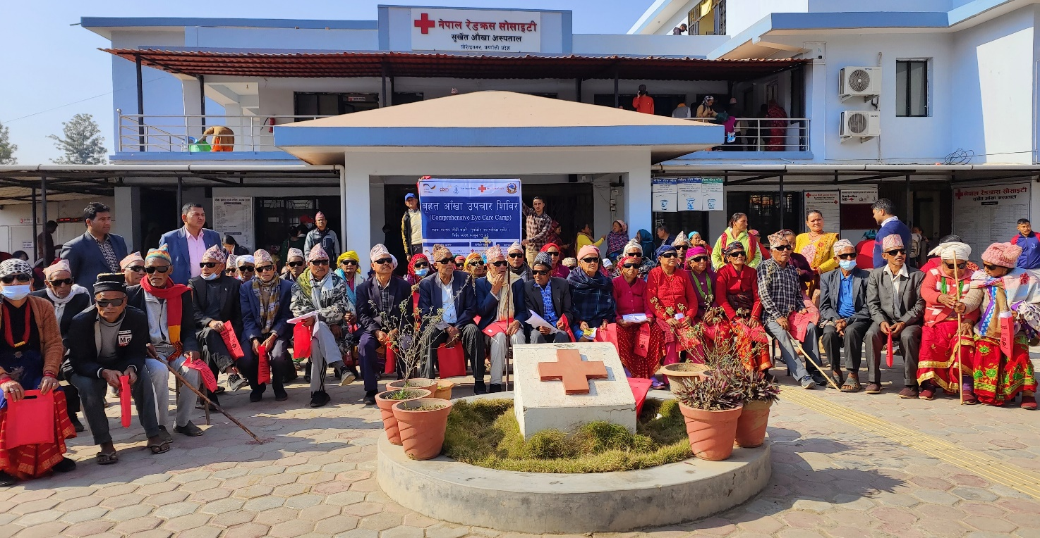

**Figure 1: Hospital Base Cataract surgeries performed at Surkhet Eye Hospital**

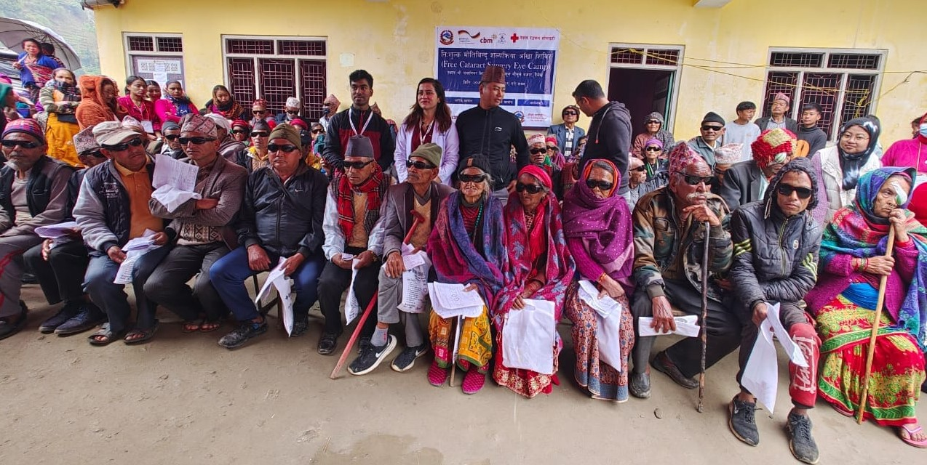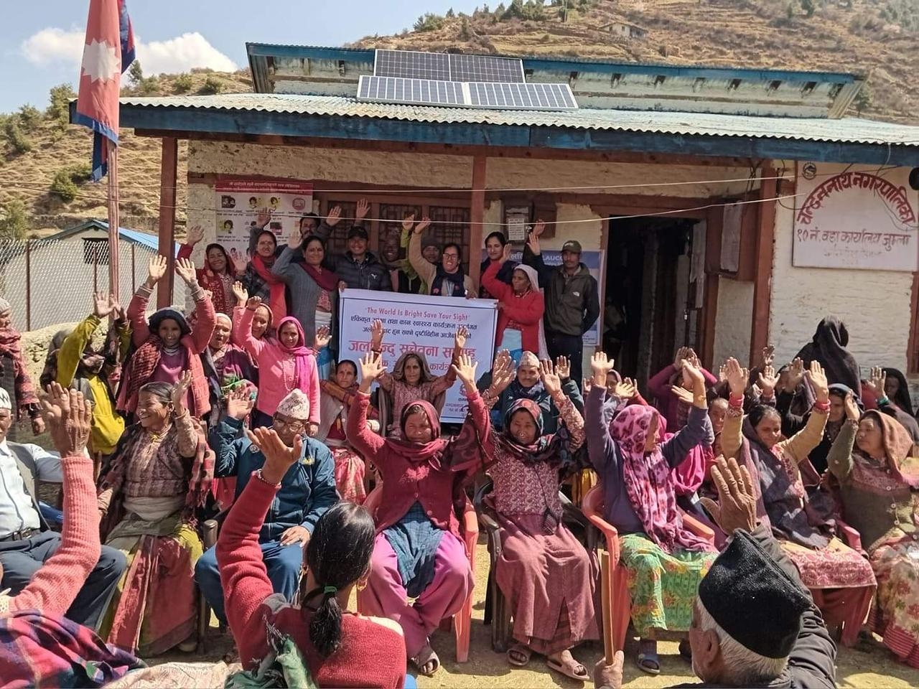

**Figure 3: Free Cataract Surgical Camp at Naumule, Dailekh**

**Figure 2: World Glaucoma Day Celebration at Chandannath, Jumla**

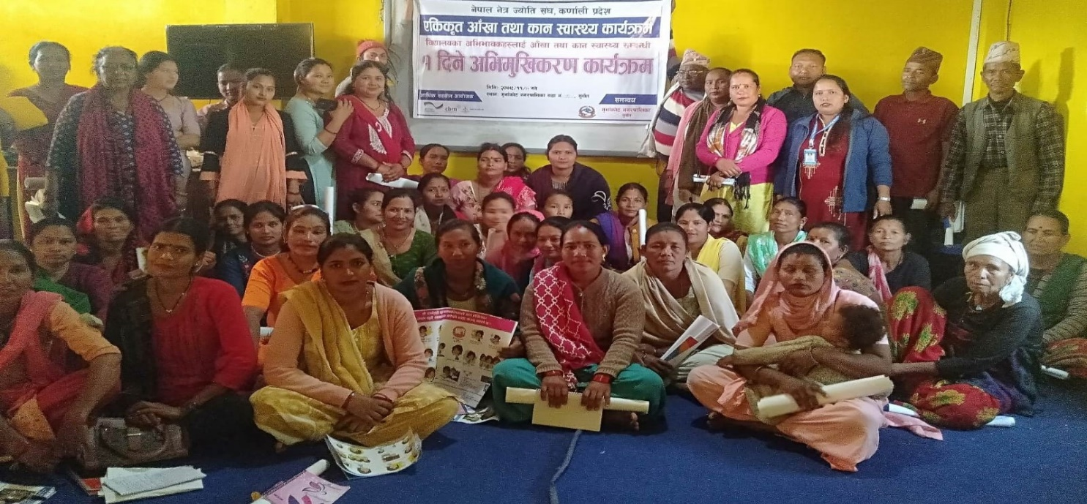

**Figure 5 : Eye Surgical Camp at Chandannath, Jumla**

**Figure 4 : Parents Orientation on eye and ear health at Mehalkuna, Gurvakot, Surkhet**

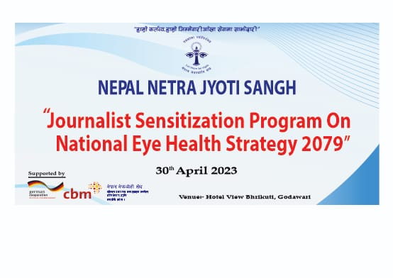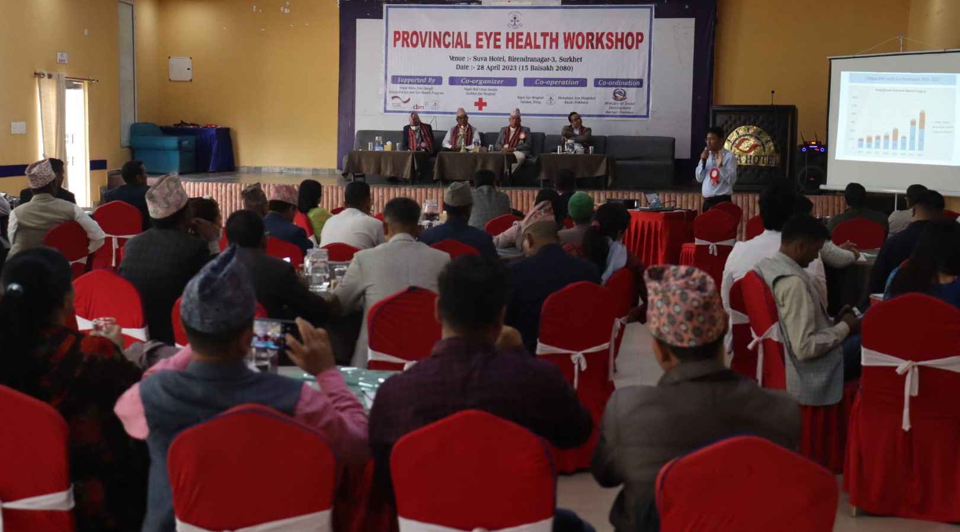

**Figure 6: Lobbying Meeting Workshop at Birendranagar, Surkhet**

**Figure 7: Journalist Sensitization Workshop in Kathmandu on Endorsed National Eye Health Strategy 2079**